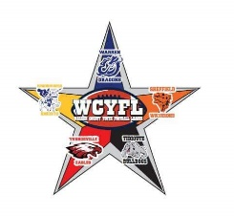

WCYFL Business Ads

.

Dear Local Business Owner,

The Warren County Youth Football League is a local non-profit organization, providing a fundamental based football program for Warren County youth from 3rd through 6th grades. The league board of directors consists of volunteers meeting year-round to organize and plan activities. Funding is provided through registration fees and donations from the community.

This season the league will also be providing football programs at our games.  A large portion of this program will contain advertisements of businesses within our community that help make this league possible.   This means you now have more options for sponsorship. Here are the possible options for donating.

Full page advertisement= $100

Half page advertisement= $75

Quarter page advertisement = $50

Eighth page advertisement= $25

Please accept this letter as a request for a Sponsorship of the Warren County Youth Football league. Please put your donation preference on the attached paper and return it in the enclosed postage marked addressed envelope. If you wish to include an advertisement in our program please include your business card or send it electronically to wcyflpa@gmail.com.

You may contact us anytime with questions or concerns.  We can also arrange for the pick-up of your donation if it is more convenient. Reference your call to Sara Nickerson, league treasurer at:

(814) 706-3998 or by email to wcyflpa@gmail.com

Thank you for your past support and we hope we can count on your support this season.

Sincerely,

Sara Nickerson and Matt Pascuzzi

WCYFL Treasurer and WCYFL President

I would like to

_________ Full page advertisement= $100

_________ Half page advertisement= $75

_________ Quarter page advertisement = $50

_________ Eighth page advertisement= $25

_________ Make a donation of  __________________

_________ I do not wish to donate.  Please do not contact me again.

Business Name_________________________________________________________________

Contact Name__________________________________________________________________

Phone Number ________________________________________________________________

_________My donation is enclosed

WCYFL Business Ads