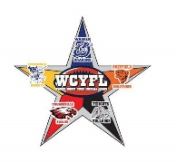

WCYFL Happy Ads

.

**All Ads MUST be PAID in FULL in order to appear in this year’s program.  Please make checks payable to WCYFL.**

**Forms MUST be RETURNED  by AUGUST 22nd.**  Please send any pictures to be included digitally to wcyflpa@gmail.com

I would like to purchase the following happy ad. Please check your preference.

**☐**  **Full page advertisement= $60**

**☐ Half page advertisement= $40**

**☐ Quarter page advertisement = $25**

**☐ Eighth page advertisement= $15**

**Player/Team Name**: ___________________________________________________

**Purchased by**: _________________________________________________________

**Message:** _____________________________________________________________

_______________________________________________________________________

_______________________________________________________________________

_______________________________________________________________________